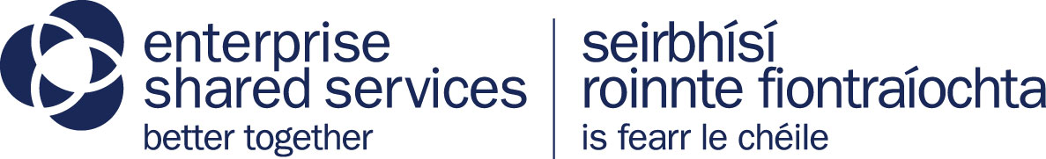 

Developer Guideloper Guide

# Contents

Contents 2

Document Information 3

Change History 3

Distribution 3

Acronyms 3

Heading 1 4

Heading 2 4

Heading 3 4

# Document Information

|  |  |  |  |
| --- | --- | --- | --- |
| Title | Developer Guide | **Version** | 1.0 |
| Author | Michael Stevenson | **Date** |  |
| Reviewed By |  | **Review Date** |  |
| RM Reference |  | **Status** |  |

# Change History

|  |  |  |  |  |  |
| --- | --- | --- | --- | --- | --- |
| Ver. No. | Ver. Date | Revised By | Description | Reviewer | Status |
| 1.0 | 21/10/2020 | Michael Stevenson | Initial Document |  |  |
|  |  |  |  |  |  |
|  |  |  |  |  |  |

# Distribution

|  |  |  |
| --- | --- | --- |
| Name | Position | Contact Details |
|  |  |  |
|  |  |  |
|  |  |  |

# Acronyms

|  |  |
| --- | --- |
| DOF | Department of Finance |
| DSS | Digital Shared Services |
| EDD | Enterprise Digital Development |
| ESS | Enterprise Shared Services |
| NICS | Northern Ireland Civil Service |

# Introduction

This document will serve as a starting guide to developers working in the **new world** of development in **Enterprise Digital Development**. This will be a guide whilst comprehensive but will not be exhaustive. Below are the current technology stacks for the **old world** (how we used to develop) and the **new world** (the future state were we are going.

**Old World**

C#, Sql server

DotNet Core

MVC

IT Assist on premises web servers

GitLab

Jenkins

Sonar Qube

**New World**

C#, MySql

DotNet Core

MVC

Gov.UK PaaS – Hosted applications in the Gov.UK cloud backed by cloud Foundry.

GitHub

Circle CI

Sonar Cloud

WhiteSource Bolt

Git Guardian

Cloud Foundry

Amazon AWS

# Starting off

Starting you will have to install the below on your nigov machine and alter some settings to get around the corporate proxy.

**Accounts**

You will need set up these accounts:

* PaaS Account
* GitHub account
* AWS account
* Circle CI account (you can do this with your GitHub Account)
* MSDN license to download Visual Studio

**Software to install**

* Cloud Foundry CF CLI – <https://github.com/cloudfoundry/cli#downloads>
* Visual Studio
* Sonar Lint Visual Studio plugin -  <https://www.sonarlint.org/visualstudio/>
* Visual Studio Code - <https://code.visualstudio.com/download>
* MySQL workbench and MySQL - <https://dev.mysql.com/downloads/windows/installer/8.0.html>
* Retire.js Chrome plugin (this checks for vulnerable libraries) - <https://chrome.google.com/webstore/detail/retirejs/moibopkbhjceeedibkbkbchbjnkadmom?hl=en>
* Axe accessibility Chrome plugin - <https://chrome.google.com/webstore/detail/axe-web-accessibility-tes/lhdoppojpmngadmnindnejefpokejbdd>
* Chrome Lighthouse Auditing tools - this is built into Chrome

How to install if software doesn’t install normally

Proxy settings

# Coding in the Open

# GDS Design system

# Developers Charter

This is just an idea to help us self-regulate our software quality and the products we deploy. We should endeavour to hone our craft and set the bar high in terms of software quality, consistency, accessibility, security and availability. The charter asks everyone to be:

* I shall do no harm intentionally
* Treat all artefacts as sacred
* Do not release vulnerable code
* Make accessibility a key feature so to make Northern Ireland service available to all of the society
* Be mindful of security
* Be open to change and new technologies
* Share everything with everyone
* Be an ambassador for our craft
* Perpetuate my craft
* Be Humble
* Continue to enjoy learning

# Accessibility

# Application Security

# Deployment Process